Vehicle-mounted FPV UAV Jammer

Model No: TTSKF09
- Product Features
- Aiming at the remote control and image transmission signals of various drones or FPV. Force the drone to return or land.
- Installed on the roof of various vehicles to protect moving vehicles.

Technical Specifications
No. | Item | Remarks
Model | TTSKF09
Working Frequency | 400-550/550-700/700-840/840-1000  1000-1300/2400-2500/5100-5300/5700-5900MHz | Support  Customized
Output Power | 400W in total
Power consumption | About 900W
Antenna Gain | 3-8dBi
Antenna working angle | Omni 360°vertical; 65°horizontal
Jamming distance | 300-2000m(Depends on jamming ratio/RC power.etc)
Power supply | DC 24-29V External battery, battery charged by AC220V
Outside Battery (Optional) | 40AH battery, 1h working
Control method | Remote Control panel
Dimension | Φ60cm*35cm
Weight | 20KG
Working temperature | -20 to +65℃

3.Product List
Item | Picture | QTY | Remark
Device | 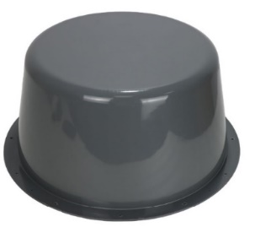 | 1
Magnet | 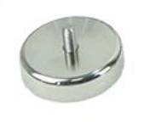 | 4-8
Battery | 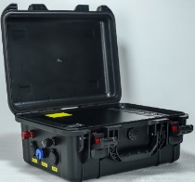 | 1 | Optional
Power Cable | 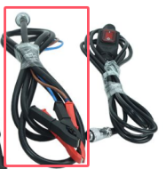 | 1
Control Panel | 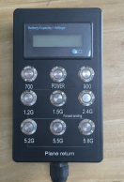 | 1 | Frequency  can customized
Screws | / | / | /
Internal Construction | 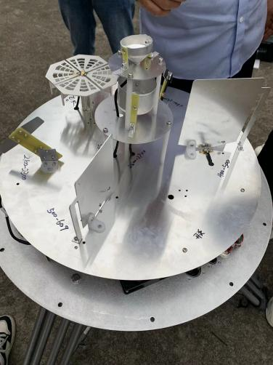 | 